# VISVESVARAYA TECHNOLOGICAL UNIVERSITY



## BELAGAVI – 590018, Karnataka INTERNSHIP REPORT

### ON

“Space Exploration Dashboard”

***Submitted in partial fulfilment for the award of degree(21IS132)***

## BACHELOR OF ENGINEERING IN INFORMATION SCIENCE AND ENGINEERING

***Submitted by:* TEJAS N 1DT21IS154**

:

Conducted at

**Varcons Technologies Pvt Ltd**

# DAYANANDA SAGAR ACADEMY OF TECHNOLOGY AND MANAGEMENT, BENGALURU

**Department of Information Science Engineering**

# Accredited by NBA, New Delhi

Opp. Art of Living, Udayapura, Kanakapura Road, Bangalore- 560082

# DAYANANDA SAGAR ACADEMY OF TECHNOLOGY AND MANAGEMENT, BENGALURU



**Department of Information Science Engineering**

# Accredited by NBA, New Delhi

Opp. Art of Living, Udayapura, Kanakapura Road, Bangalore- 560082

**CERTIFICATE**

This is to certify that the Internship titled **“Space Exploration Dashboard”** carried out by **Mr. Tejas N,** a bonafide student of Dayananda sagar academy of technology and management Institute , in partial fulfillment for the award of **Bachelor of Engineering**, in **Information Science and Engineering** under Visvesvaraya Technological University, Belagavi, during the year 2022-2023. It is certified that all corrections/suggestions indicated have been incorporated in the report.

The project report has been approved as it satisfies the academic requirements in respect of Internship prescribed for the course Internship / Professional Practice (21CSI85)

### Signature of Guide Signature of HOD Signature of Principal

**External Viva:**

Name of the Examiner Signature with Date

1)

2)

# D E C L A R A T I O N

**I**, **TEJAS N** ,pre-final year student of Information Science and Engineering , Dayananda Sagar Academy of technology - 560 082, declare that the Internship has been successfully completed, in **Varcons Technologies Pvt Ltd**. This report is submitted in partial fulfillment of the requirements for award of Bachelor Degree in Information Science and Engineering, during the academic year 2022-2023.

Date : 02/12/2023 Place : Bangalore

USN : 1DT21IS154 NAME : TEJAS N

**OFFER LETTER**

INTERNSHIP OFFER LETTER

Date: 25th October, 2023

Name: **TEJAS N**

USN: **1DT21IS154**

**Dear Student,**

We would like to congratulate you on being selected for the **Full Stack Web Development** Internship position with **Varcons Technologies**, effective Start Date **25th October, 2023**, All of us are excited about this opportunity provided to you!

This internship is viewed as being an educational opportunity for you, rather than a part-time job. As such, your internship will include training/orientation and focus primarily on learning and developing new skills and gaining a deeper understanding of concepts of **Full Stack Web Development** through hands-on application of the knowledge you learn while you train with the senior developers. You will be bound to follow the rules and regulations of the company during your internship duration.

Again, congratulations and we look forward to working with you!. Sincerely,

Spoorthi H C

**Director**

VARCONS TECHNOLOGIES

*213, 2st Floor,*

*18 M G Road, Ulsoor, Bangalore-560001*

# A C K N O W L E D G E M E N T

This Internship is a result of accumulated guidance, direction and support of several important persons. We take this opportunity to express our gratitude to all who have helped us to complete the Internship.

We express our sincere thanks to our Principal, for providing us adequate facilities to undertake this Internship.

We would like to thank our Head of Dept – ISE, for providing us an opportunity to carry out Internship and for his valuable guidance and support.

We would like to thank our (Lab assistant name) Software Services for guiding us during the period of internship.

We express our deep and profound gratitude to our guide, Guide name, Assistant/Associate Prof, for her keen interest and encouragement at every step in completing the Internship.

We would like to thank all the faculty members of our department for the support extended during the course of Internship.

We would like to thank the non-teaching members of our dept, for helping us during the Internship.

Last but not the least, we would like to thank our parents and friends without whose constant help, the completion of Internship would have not been possible.

**NAME:TEJAS N USN:1DT21IS154**

# ABSTRACT

As a part of project for internship, we as a team of 3 have come to the conclusion of doing the following:

Title: Tej Space Dashboard Website - Abstract

The WEB Space Dashboard website represents a modern and engaging platform designed to provide users with a comprehensive experience related to space exploration. The website features multiple sections, each serving a unique purpose to inform and captivate visitors.

Key Features:

1. Navigation and Branding:

- The website incorporates a clean and visually appealing design, featuring a prominent logo and navigation menu for easy user interaction.

- Utilizes the Boxicons library for stylish and consistent iconography.

2. Sections:

Home Section:

- Welcomes users with an animated home section, showcasing a captivating tagline and a call-to-action button for user engagement.

Flight List Section:

- Highlights key celestial bodies like Neptune, Mars, Mercury, and Uranus, providing informative content about each planet.

- Each planet is accompanied by an enticing image and an invitation to join the space exploration experience.

Mission History Section:

- Showcases a visually striking animation of a spaceship, emphasizing the website's claim to having the best space shuttle on Earth.

- Offers a compelling narrative about the organization's space exploration journey, inviting users to join.

Shop Section:

- Presents a curated selection of space-related products with detailed descriptions, images, and pricing.

- Includes a "Shop Now" button for each product, encouraging users to explore and make purchases.

Experience Section:

- Features an engaging animation of an astronaut with a dynamic background, emphasizing the organization's 10 years of experience in space exploration.

- Provides a descriptive text highlighting achievements and expertise, along with a call-to-action button for user involvement.

3. Footer:

- Comprises a well-organized footer with quick links, social media icons, and contact information.

- Quick links facilitate easy navigation to key sections, enhancing user experience.

- Social media links enable users to connect with the organization on various platforms.

- Contact details, including phone numbers and email addresses, offer multiple channels for communication.

4. Copyright and Scroll-to-Top:

- Displays copyright information at the bottom of the page.

- Includes a "Scroll-to-Top" button for convenient navigation back to the top of the page.

5. Responsive Design:

- Implements a responsive design approach, ensuring optimal user experience across various devices and screen sizes.

In summary, the WEB Space Dashboard website blends aesthetics with functionality, creating an immersive space exploration journey for visitors. It successfully combines informative content, interactive elements, and a user-friendly interface to cater to a diverse audience interested in the wonders of the cosmos.

We hope, that the project meets the requirements. We are immensely grateful to have been provided with such an amazing learning experience.

# Table of Contents

|  |  |  |
| --- | --- | --- |
| **Sl no** | **Description** | **Page no** |
| 1 | Company Profile | 9-10 |
| 2 | About the Company | 11-14 |
| [3](https://1.bp.blogspot.com/-dODuK8N5h1Q/Wlnyb3V9HFI/AAAAAAAACL4/WxQtCJ1pM5wccDABg4wIrTBUB0vlikXQQCLcBGAs/s1600/poly1.jpg) | Introduction | 15-17 |
| [4](https://1.bp.blogspot.com/-dODuK8N5h1Q/Wlnyb3V9HFI/AAAAAAAACL4/WxQtCJ1pM5wccDABg4wIrTBUB0vlikXQQCLcBGAs/s1600/poly1.jpg) | System Analysis | 18-20 |
| [5](https://1.bp.blogspot.com/-dODuK8N5h1Q/Wlnyb3V9HFI/AAAAAAAACL4/WxQtCJ1pM5wccDABg4wIrTBUB0vlikXQQCLcBGAs/s1600/poly1.jpg) | Requirement Analysis | 21-22 |
| 6 | Design [Analysis](https://4.bp.blogspot.com/-IOOxgPaXMVc/Wlj3LWvcnjI/AAAAAAAACKE/UeTFYvAxDmUDel5UBjdifeWaApB3-dXVgCLcBGAs/s1600/img1.jpg) | 23-25 |
| 7 | [Implementation](https://4.bp.blogspot.com/-IOOxgPaXMVc/Wlj3LWvcnjI/AAAAAAAACKE/UeTFYvAxDmUDel5UBjdifeWaApB3-dXVgCLcBGAs/s1600/img1.jpg) | 26-27 |
| 8 | Snapshots | 28-31 |
| 9 | Conclusion | 32-33 |
| 10 | References | 34 |

[**CHAPTER**](https://1.bp.blogspot.com/-dODuK8N5h1Q/Wlnyb3V9HFI/AAAAAAAACL4/WxQtCJ1pM5wccDABg4wIrTBUB0vlikXQQCLcBGAs/s1600/poly1.jpg) **1 COMPANY PROFILE**

# COMPANY PROFILE

**A Brief History of Varcons Technologies**

Varcons Technologies, was incorporated with a goal ”To provide high quality and optimal Technological Solutions to business requirements of our clients”. Every business is a different and has a unique business model and so are the technological requirements. They understand this and hence the solutions provided to these requirements are different as well. They focus on clients requirements and provide them with tailor made technological solutions. They also understand that Reach of their Product to its targeted market or the automation of the existing process into e- client and simple process are the key features that our clients desire from Technological Solution they are looking for and these are the features that we focus on while designing the solutions for their clients.

Sarvamoola Software Services. is a Technology Organization providing solutions for all web design and development, MYSQL, PYTHON Programming, HTML, CSS, ASP.NET and LINQ. Meeting the ever increasing automation requirements, Sarvamoola Software Services. specialize in ERP, Connectivity, SEO Services, Conference Management, effective web promotion and tailor-made software products, designing solutions best suiting clients requirements.

Varcons Technologies, strive to be the front runner in creativity and innovation in software development through their well-researched expertise and establish it as an out of the box software development company in Bangalore, India. As a software development company, they translate this software development expertise into value for their customers through theirprofessional solutions.

They understand that the best desired output can be achieved only by understanding the clients demand better. Varcons Technologies work with their clients and help them todefiine their exact solution requirement. Sometimes even they wonder that they have completely redefined their solution or new application requirement during the brainstormingsession, and here they position themselves as an IT solutions consulting group comprising of high caliber consultants.

They believe that Technology when used properly can help any business to scale and achieve new heights of success. It helps Improve its efficiency, profitability, reliability; to put it in one sentence ” Technology helps you to Delight your Customers” and that is what we want to achieve.

# [CHAPTER](https://1.bp.blogspot.com/-dODuK8N5h1Q/Wlnyb3V9HFI/AAAAAAAACL4/WxQtCJ1pM5wccDABg4wIrTBUB0vlikXQQCLcBGAs/s1600/poly1.jpg) 2 ABOUT THE COMPANY

* 1. **ABOUT THE COMPANY**

Varcons Technologies is a Technology Organization providing solutions for all web design and development, MYSQL, PYTHON Programming, HTML, CSS, ASP.NET and LINQ. Meeting the ever increasing automation requirements, Varcons Technologies specialize in ERP, Connectivity, SEO Services, Conference Management, effective web promotion and tailor-made software products, designing solutions best suiting clients requirements. The organization where they have a right mix of professionals as a stakeholders to help us serve our clients with best of our capability and with at par industry standards. They have young, enthusiastic, passionate and creative Professionals to develop technological innovations in the field of Mobile technologies, Web applications as well as Business and Enterprise solution. Motto of our organization is to “Collaborate with our clients to provide them with best Technological solution hence creating Good Present and Better Future for our client which will bring a cascading a positive effect in their business shape as well”. Providing a Complete suite of technical solutions is not just our tag line, it is Our Vision for Our Clients and for Us, We strive hard to achieve it.

Products of Varcons Technologies.

**Android Apps**

It is the process by which new applications are created for devices running the Android operating system. Applications are usually developed in Java (and/or Kotlin; or other such option) programming language using the Android software development kit (SDK), but other development environments are also available, some such as Kotlin support the exact same Android APIs (and bytecode), while others such as Go have restricted API access.

The Android software development kit includes a comprehensive set of development tools. These include a debugger, libraries, a handset emulator based on QEMU, documentation, sample code, and zutorials. Currently supported development platforms include computers running Linux (any modern desktop Linux distribution), Mac OS X 10.5.8 or later, and Windows 7 or later. As of March 2015, the SDK is not available on Android itself, but softwaredevelopment is possible by using specialized Android applications.

**Web Application**

It is a client–server computer program in which the client (including the user interface and client- side logic) runs in a web browser. Common web applications include web mail, online

retail sales, online auctions, wikis, instant messaging services and many other functions. web applications use web documents written in a standard format such as HTML and JavaScript,which are supported by a variety of web browsers. Web applications can be considered as a specifific variant of client–server software where the client software is downloaded to the client machine when visiting the relevant web page, using standard procedures such as HTTP. The Client web software updates may happen each time the web page is visited. During the session, the web browser interprets and displays the pages, and acts as the universal client for any web application. The use of web application frameworks can often reduce the number of errors in a program, both by making the code simpler, and by allowing one team to concentrate on the framework while another focuses on a specifified use case. In applications which are exposed to constant hacking attempts on the Internet, security- related problems can be caused by errors in the program.

Frameworks can also promote the use of best practices such as GET after POST. There are some who view a web application as a two-tier architecture. This can be a “smart” client that performs all the work and queries a “dumb” server, or a “dumb” client that relies on a “smart” server. The client would handle the presentation tier, the server would have the database (storage tier), and the business logic (application tier) would be on one of them or on both. While this increases the scalability of the applications and separates the display and the database, it still doesn‟t allow for true specialization of layers, so most applications will outgrow this model. An emerging strategy for application software companies is to provide web access to software previously distributed as local applications. Depending on the type of application, it may require the development of an entirely different browser-based interface, or merely adapting an existing application to use different presentation technology. These programs allow the user to pay a monthly or yearly fee for use of a software application without having to install it on a local hard drive. A company which follows this strategy is known as an application service provider (ASP), and ASPs are currently receiving much attention in the software industry.

Security breaches on these kinds of applications are a major concern because it can involve both enterprise information and private customer data. Protecting these assets is an important part of any web application and there are some key operational areas that must be included in the development process. This includes processes for authentication, authorization, asset handling, input, and logging and auditing. Building security into the applications from the beginning can be more effective and less disruptive in the long run.

**Web design**

It is encompasses many different skills and disciplines in the production and maintenance of websites. The different areas of web design include web graphic design; interface design; authoring, including standardized code and proprietary software; user experience design; and

search engine optimization. The term web design is normally used to describe the design process relating to the front-end (client side) design of a website including writing mark up. Web design partially overlaps web engineering in the broader scope of web development. Web designers are expected to have an awareness of usability and if their role involves creating mark up then they are also expected to be up to date with web accessibility guidelines. Web design partially overlaps web engineering in the broader scope of web development.

## Departments and services offered

Compsoft Technologies plays an essential role as an institute, the level of education, development of student’s skills are based on their trainers. If you do not have a good mentor then you may lag in many things from others and that is why we at Compsoft Technologies gives you the facility of skilled employees so that you do not feel unsecured about the academics. Personality development and academic status are some of those things which lie on mentor’s hands. If you are trained well then you can do well in your future and knowing its importance of Compsoft Technologies always tries to give you the best.

They have a great team of skilled mentors who are always ready to direct their trainees in the best possible way they can and to ensure the skills of mentors we held many skill development programs as well so that each and every mentor can develop their own skills with the demands of the companies so that they can prepare a complete packaged trainee.

## Services provided by Varcons Technologies.

* Core Java and Advanced Java
* Web services and development
* Dot Net Framework
* Python
* Selenium Testing
* Conference / Event Management Service
* Academic Project Guidance
* On The Job Training
* Software Training

# [CHAPTER](https://1.bp.blogspot.com/-dODuK8N5h1Q/Wlnyb3V9HFI/AAAAAAAACL4/WxQtCJ1pM5wccDABg4wIrTBUB0vlikXQQCLcBGAs/s1600/poly1.jpg) 3 INTRODUCTION

* 1. **INTRODUCTION**

## Introduction to Web Development

Web development refers to the process of creating and maintaining websites or web applications for the Internet or an intranet. It encompasses a wide range of activities, including web design, web content development, client-side/server-side scripting, and network security configuration. Web development plays a crucial role in establishing an online presence for individuals, businesses, and organizations

## Problem Statement

The WEB Space Dashboard website aims to address the following challenges and objectives in the field of space exploration:

1. User Engagement and Information Dissemination:

- Develop an interactive and visually appealing platform to engage users with the wonders of space exploration.

- Provide comprehensive information about celestial bodies, space missions, and the organization's expertise to foster public interest and awareness.

2. E-commerce Integration:

- Implement an efficient and user-friendly e-commerce section to facilitate the sale of space-related products.

- Ensure secure transactions, detailed product descriptions, and an intuitive shopping experience for visitors interested in purchasing space-themed merchandise.

3. Brand Identity and Communication:

- Establish a strong brand identity through an attractive logo, consistent iconography, and a cohesive visual theme throughout the website.

- Effectively communicate the organization's mission, achievements, and 10 years of experience in space exploration to build trust and credibility among users.

4. Responsive Design and Accessibility:

- Create a responsive design that adapts seamlessly to various devices and screen sizes, ensuring a consistent and user-friendly experience across platforms.

- Prioritize accessibility features to make the website inclusive and easily navigable for users with diverse needs.

5. Social Media Integration:

- Integrate social media links to connect with a broader audience and promote the organization's activities on platforms such as Instagram, Facebook, LinkedIn, and Twitter.

- Enhance the website's reach and engagement by leveraging the power of social media for information dissemination and community building.

6. Call-to-Action and User Participation:

- Strategically place call-to-action buttons throughout the website to encourage user participation, such as joining the space exploration journey or exploring and purchasing products from the shop.

- Foster a sense of community by inviting users to actively engage with the organization's mission and initiatives.

7. Aesthetic Appeal and Brand Consistency:

- Ensure a visually appealing and cohesive design that aligns with the theme of space exploration and aligns with the organization's brand.

- Maintain consistency in design elements, color schemes, and typography to enhance the overall aesthetic appeal of the website.

8. Website Performance and Scalability:

- Optimize website performance to ensure fast loading times and smooth navigation.

- Design the website with scalability in mind, accommodating potential growth in content and user interactions over time.

The WEB Space Dashboard website aims to overcome these challenges to provide a compelling and immersive online experience for individuals interested in space exploration, science, and related products.

# [CHAPTER](https://1.bp.blogspot.com/-dODuK8N5h1Q/Wlnyb3V9HFI/AAAAAAAACL4/WxQtCJ1pM5wccDABg4wIrTBUB0vlikXQQCLcBGAs/s1600/poly1.jpg) 4 SYSTEM ANALYSIS

* 1. **SYSTEM ANALYSIS**

The provided HTML and CSS code represents a web page for a "Space Dashboard." In order to discuss the existing system, proposed system, and the objectives of the system, we'll make some assumptions and provide a general analysis.

**Existing System:**

The existing system is not explicitly described in the provided code, but we can make some assumptions based on common practices for web development. The existing system would typically represent the absence of the "Space Dashboard" website or an older version of it. Before the development of the current webpage, there might not have been a dedicated platform for users interested in space-related information, products, and experiences.

**Proposed System:**

The proposed system is the "Space Dashboard" website represented by the provided HTML and CSS code. It serves as a platform for users interested in various aspects of space, including information about planets, space missions, a shop for space-related products, and an overview of the organization's experience. The proposed system aims to provide a visually appealing, informative, and user-friendly interface for individuals passionate about space exploration.

**Objectives of the System:**

1. Information Dissemination:

- Existing System: Limited or no dedicated platform for space-related information.

- Proposed System: To offer detailed information about different planets, space missions, and the organization's expertise in space-related activities.

2. User Engagement:

- Existing System: Limited or no user interaction on a dedicated space-themed website.

- Proposed System: To engage users with visually appealing content, including images, descriptions, and calls-to-action for further engagement.

3. E-commerce Functionality:

Existing System : No online shop for space-related products.

Proposed System: To provide users with the ability to browse and purchase space-related products through the online shop.

4. Enhanced User Experience:

- Existing System: Potential lack of a modern and visually pleasing user interface.

- Proposed System: To create an attractive and responsive design that enhances the overall user experience.

5. Promotion of Services:

- Existing System: No platform to showcase the organization's space-related services.

- Proposed System: To promote the organization's services, including space missions and experiences, with the aim of attracting users to join and participate.

6. Social Media Integration:

- Existing System: Potential absence of integration with social media platforms.

- Proposed System: To leverage social media integration for wider reach and interaction, as suggested by the presence of social media icons in the footer.

7. Responsive Design:

- Existing System: Potential lack of responsiveness for different screen sizes.

- Proposed System: To ensure a responsive design that adapts to various devices, as indicated by the presence of media queries in the CSS.

8. Brand Establishment:

- Existing System: No dedicated online presence for the organization's brand.

- Proposed System: To establish and strengthen the organization's online brand presence in the space-related community.

9. User Interaction:

- Existing System: Limited or no means for users to actively engage with the content.

- Proposed System: To provide interactive elements, such as buttons and navigation, allowing users to explore and engage with the presented content.

.

# [CHAPTER](https://1.bp.blogspot.com/-dODuK8N5h1Q/Wlnyb3V9HFI/AAAAAAAACL4/WxQtCJ1pM5wccDABg4wIrTBUB0vlikXQQCLcBGAs/s1600/poly1.jpg) 5 REQUIREMENT ANALYSIS

**5. REQUIREMENT ANALYSIS**

## Hardware Requirement Specification

### Central Processing Unit (CPU):

* + - The system necessitates a CPU with substantial computational capabilities to effectively execute machine learning algorithms.

### Random-Access Memory (RAM):

* + - A minimum of 8GB of RAM is advised to ensure seamless processing of extensive datasets and efficient model training.

### Storage Capacity:

* + - Adequate storage space is essential to accommodate the machine learning model, training datasets, and the application itself.

### Graphics Processing Unit (GPU):

* + - Although not mandatory, a GPU expedites the training process.

### Display:

* + - A standard display with a resolution of 1280x720 or higher

## Software Requirement Specification

**Visual Studio:**

1. Category: Integrated Development Environment (IDE)

2. Purpose:

- Development: Visual Studio is primarily used for software development, supporting a wide range of programming languages such as C#, C++, VB.NET, F#, Python, and more.

- Web Development: It offers tools for web development, including HTML, CSS, JavaScript, and support for frameworks like ASP.NET.

.3.Versions:

-Visual Studio Code (VS Code): A lightweight, cross-platform code editor with support for various languages.

**Figma:**

1. Category: UI/UX Design and Prototyping Tool

2. Purpose:

- Figma is a cloud-based design tool used for creating user interfaces, prototypes, and collaborative design projects.

- It's widely used in the field of user experience (UX) and user interface (UI) design.

3. Key Features:

- Vector Editing: Tools for creating and editing vector graphics.

- Prototyping: Interactive prototyping to simulate user flows and interactions.

- Collaboration: Real-time collaboration, allowing multiple users to work on the same project simultaneously.

- Cloud Storage: Designs are stored in the cloud, making them accessible from anywhere.

# [CHAPTER](https://1.bp.blogspot.com/-dODuK8N5h1Q/Wlnyb3V9HFI/AAAAAAAACL4/WxQtCJ1pM5wccDABg4wIrTBUB0vlikXQQCLcBGAs/s1600/poly1.jpg) 6 DESIGN ANALYSIS

**6. DESIGN & ANALYSIS**

The provided code is for a space-themed website and involves both HTML and CSS. Let's analyze the design aspects of the code:

**Design Analysis:**

**HTML Structure:**

1. Header Section:

- The header includes a logo, navigation links, a login button, and a menu icon.

- The logo has an image and text, contributing to brand identity.

- Navigation links have smooth scrolling to different sections.

2. Home Section:

- Features a prominent heading, subheading, and a call-to-action button.

- Animated images of Earth, a floating object, and a moon light effect create a visually appealing home section.

3. Flight List Section:

- Displays information about different planets with images, descriptions, and "Join with us" buttons.

- Each planet is presented in a box with a background image, contributing to a visually engaging presentation.

4. Mission History Section:

- Showcases an animated spaceship image with a description.

- The animated circle effect adds a dynamic visual element.

5. Shop Section:

- Presents various products with images, prices, and descriptions.

- Each product has a "Shop now" button, creating a clear call-to-action for users.

6. Experience Section:

- Features an animated astronaut image with a description.

- The circle animation effect adds a visually interesting element.

7. Footer Section:

- Divided into different sections for company information, quick links, and contact details.

- Social media icons, quick links, and contact information contribute to user engagement and accessibility.

8. Copyright Section:

- Provides copyright information and an upward arrow for smooth scrolling to the top.

**CSS Styling:**

1. General Styling:

- Custom font usage adds a unique visual style to the entire website.

- Background images, colors, and box shadows are applied for a cohesive theme.

2. Header Styling:

- The header has a fixed position, providing easy navigation for users.

- Responsive design is implemented for various screen sizes.

3. Section Styling:

- Each section has its own distinct styling, contributing to a thematic and visually appealing design.

- Animation effects, such as floating and rotating, enhance the visual interest of the content.

4. Footer Styling:

- The footer is well-organized with a balanced layout for company information, quick links, and contact details.

- Social media icons are styled for a clean and recognizable appearance.

5. Media Queries:

- Media queries ensure that the design is responsive and adapts to different screen sizes.

# [CHAPTE](https://1.bp.blogspot.com/-dODuK8N5h1Q/Wlnyb3V9HFI/AAAAAAAACL4/WxQtCJ1pM5wccDABg4wIrTBUB0vlikXQQCLcBGAs/s1600/poly1.jpg)R 7 IMPLEMENTATION

**7. IMPLEMENTATION**

1. HTML File:

- Create a new HTML file, for example, `index.html`.

- Copy and paste the HTML code into this file.

2. CSS File:

- Create a new CSS file, for example, `style.css`.

- Copy and paste the CSS code into this file.

3. Images:

- Make sure you have the necessary images (`imglogo.png`, `hero.png`, `light-moon.png`, etc.) referenced in the HTML code.

- Create an `img` folder and place the images inside it.

4. External Libraries:

- Ensure you have an internet connection to access external libraries.

- The code uses the Boxicons library from a CDN (`https://unpkg.com/boxicons@2.1.4/css/boxicons.min.css`).

- Make sure the library is accessible or consider downloading and hosting it locally.

5. Testing:

- Open the HTML file in a web browser to see the webpage.

- Test the responsiveness and functionality of different sections.

# [CHAPTE](https://1.bp.blogspot.com/-dODuK8N5h1Q/Wlnyb3V9HFI/AAAAAAAACL4/WxQtCJ1pM5wccDABg4wIrTBUB0vlikXQQCLcBGAs/s1600/poly1.jpg)R 8 SNAPSHOTS

* 1. **SNAPSHOTS**

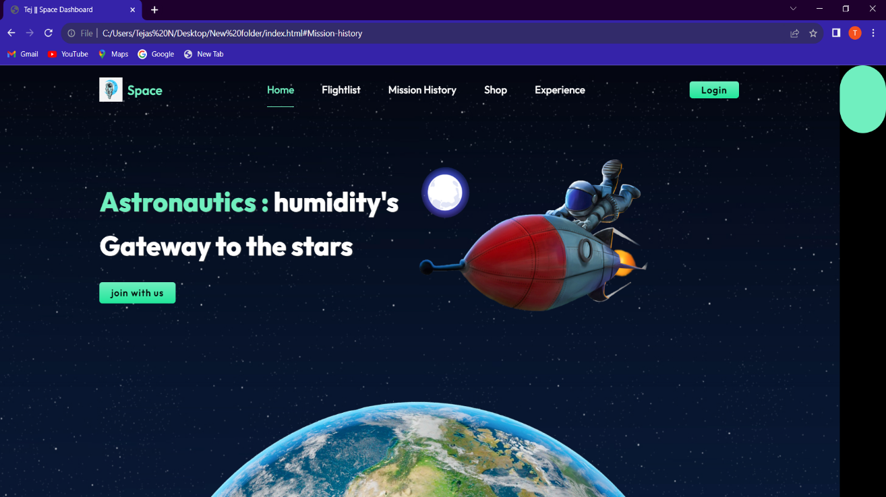

Figure : HOME

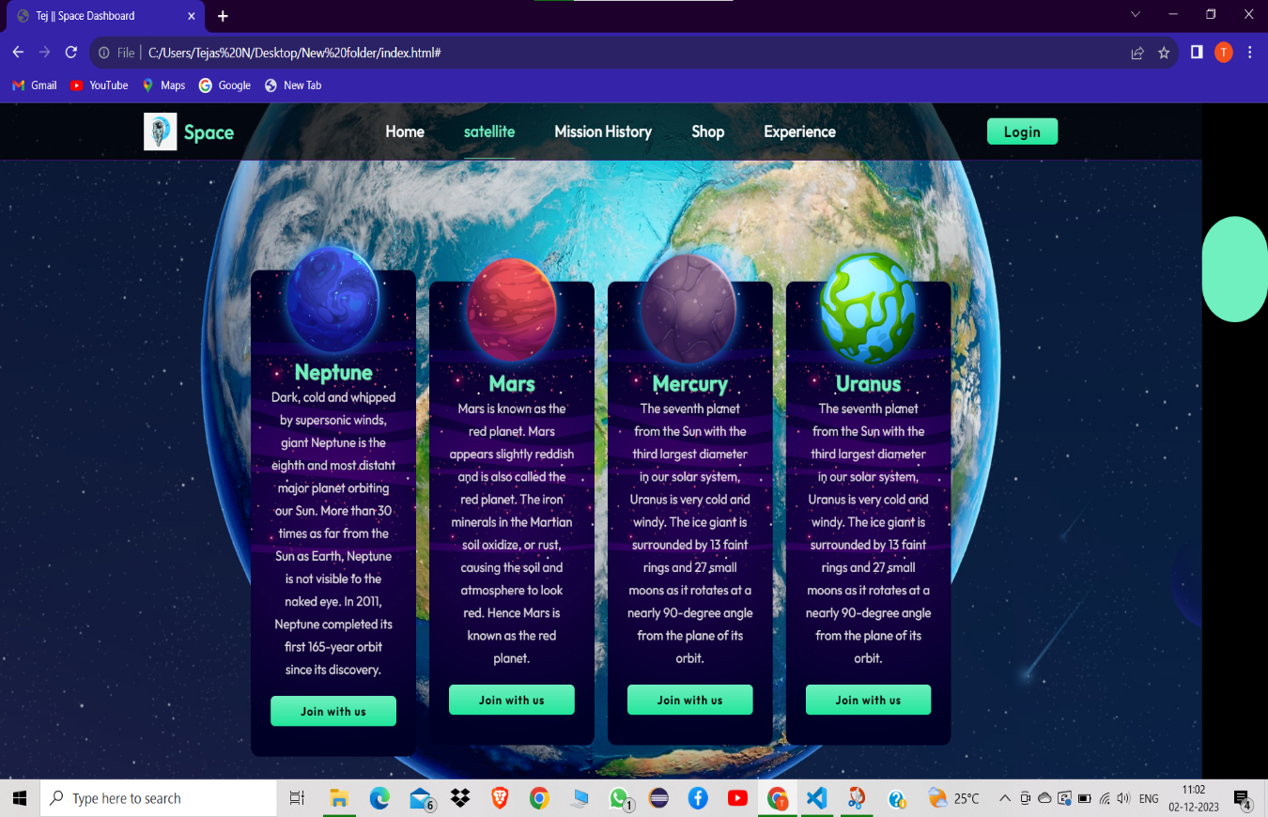

Figure :Satellite page

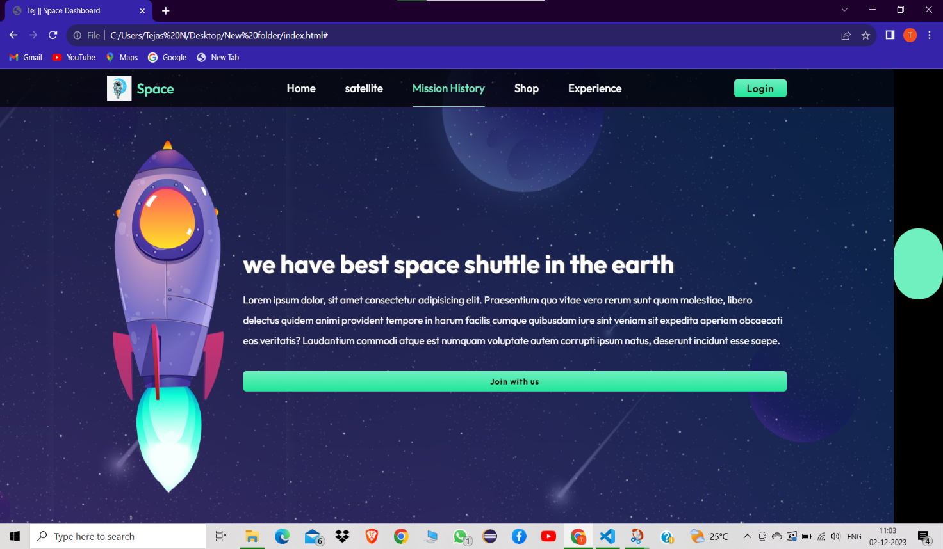

Figure :mission page

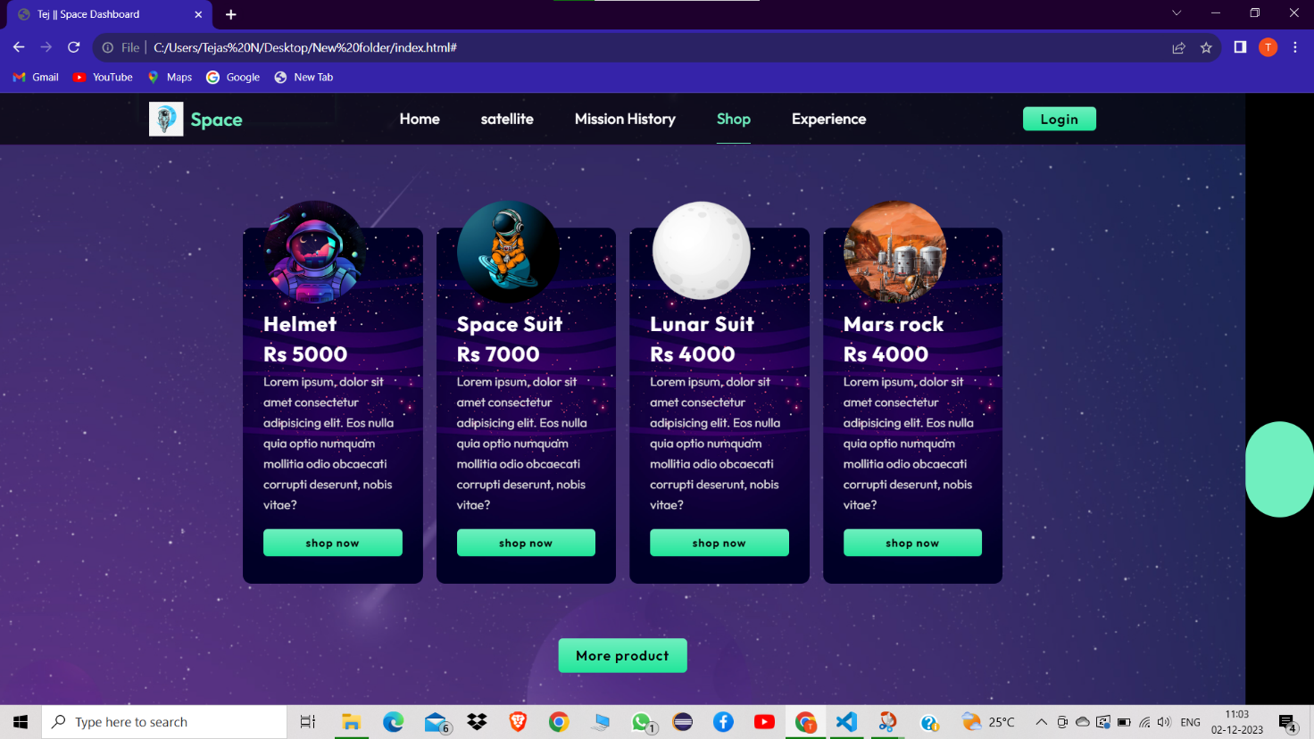

Figure :shopping page

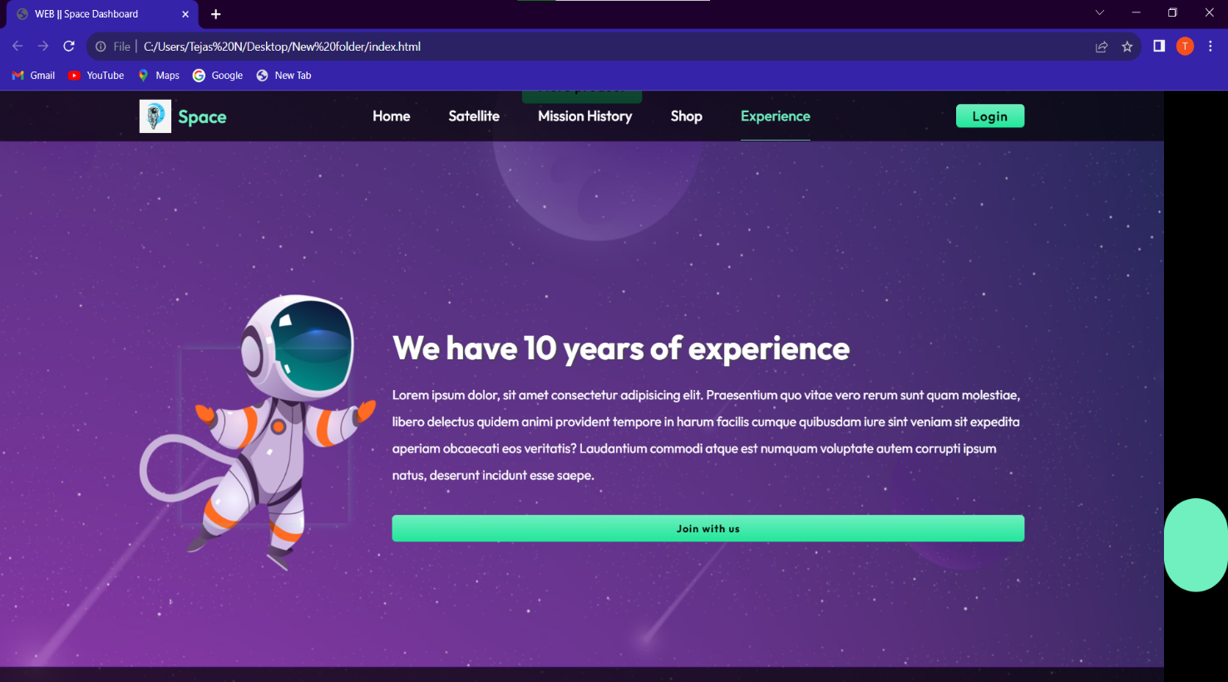

Figure :EXPERIENCE PAGE

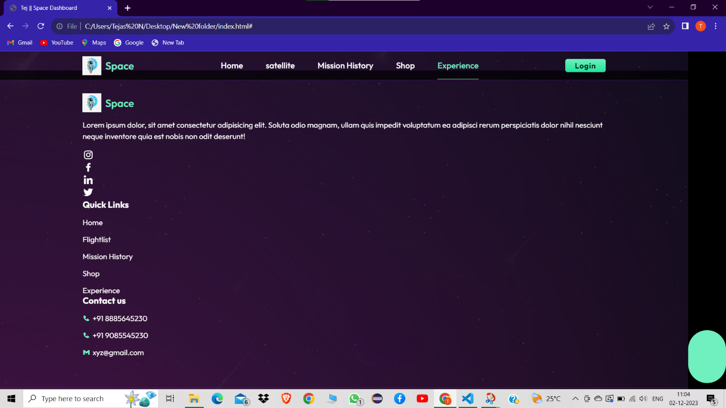

Figure :CONTACT DASHBOARD

# [CHAPTE](https://1.bp.blogspot.com/-dODuK8N5h1Q/Wlnyb3V9HFI/AAAAAAAACL4/WxQtCJ1pM5wccDABg4wIrTBUB0vlikXQQCLcBGAs/s1600/poly1.jpg)R 9 CONCLUSION

* 1. **CONCLUSION**

The provided HTML and CSS code creates a simple one-page space exploration dashboard. The dashboard includes a header with the title, a main content section presenting information, and a footer with copyright details. The styling is clean and responsive, ensuring a pleasant user experience.

In the "Conclusion" section, the text emphasizes the significance of space exploration, highlighting its role in expanding human knowledge and technological capabilities. It mentions the dashboard's purpose in showcasing achievements and ongoing projects, with a forward-looking perspective on collaboration and technological advancements.

Continuing with the space exploration dashboard, you might want to enhance the functionality and visual appeal. Here are some suggestions:

1. Dynamic Data Integration:

Consider incorporating dynamic data by connecting to APIs that provide real-time information on space missions, astronomical events, or satellite positions. Use JavaScript to fetch and update the content dynamically.

2. Interactive Elements:

Introduce interactive elements like charts or graphs to visualize data trends. Libraries such as Chart.js or D3.js can help create engaging visual representations of space-related statistics.

3. Mission Details Section:

Expand the dashboard to include a section with detailed information about ongoing and upcoming space missions. Include launch dates, mission objectives, and live countdowns if applicable.

4. Social Media Integration:

Add social media sharing buttons or feeds to encourage users to share interesting space discoveries directly from the dashboard.

5. Responsive Design:

Ensure the dashboard is fully responsive to different screen sizes and devices. This is crucial for a seamless user experience on both desktop and mobile platforms.

Remember to test the dashboard across various browsers and devices to ensure a consistent and optimal user experience. By incorporating these enhancements, you can create a more engaging and informative space exploration dashboard.

# REFERENCE

**Youtube reference**: https://youtu.be/dK4tBzwaGbY?si=Sb0-_LDikYtn96aK